  
  
  
**Parallel and Distributed Computing  
CSE4001**

***Lab Assignment 5***

Slot : L21+L22

Name : Kulvir Singh

Register Number : 19BCE2074

**Question 1 : Implement the MPI Status problem**

***AIM and PROCEDURE :***



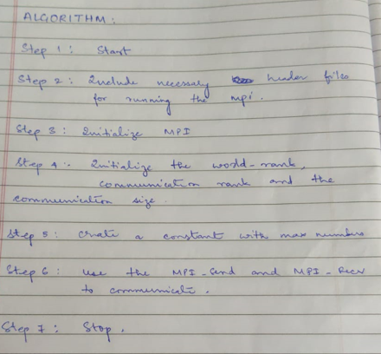

**Code Screenshot - >**

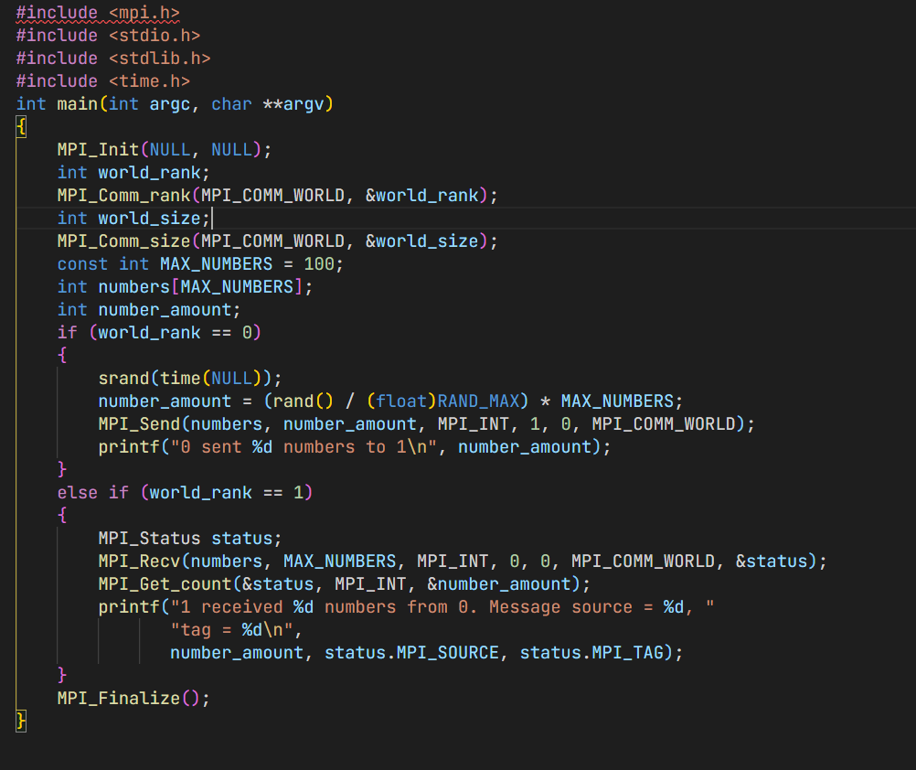

**Output Screenshot ->**

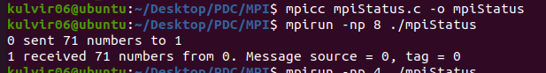

**Inference  
The program successfully implements the status problem in MPI as seen in the output**

**Question 2 : Implement the MPI Broadcasting algorithm**

***AIM and PROCEDURE :***

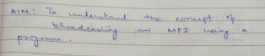

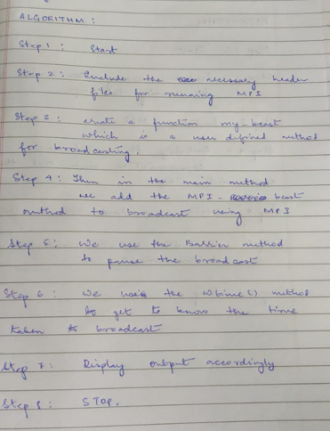

**Code Screenshot - >**

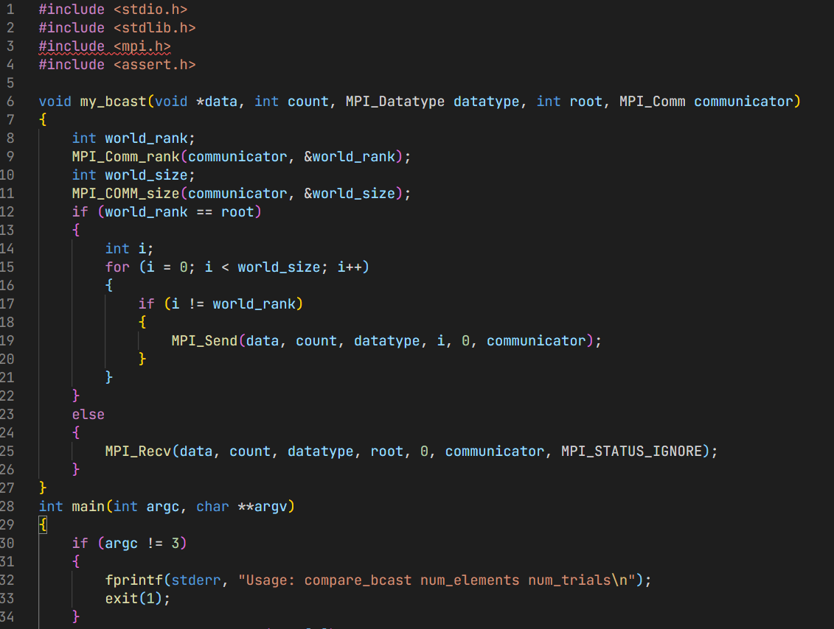

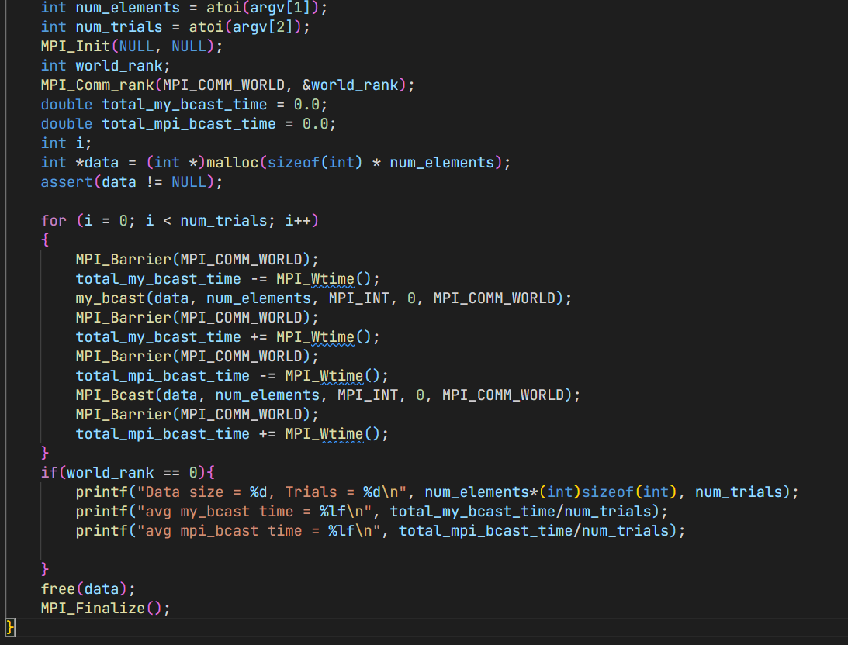

**Output Screenshot - >**

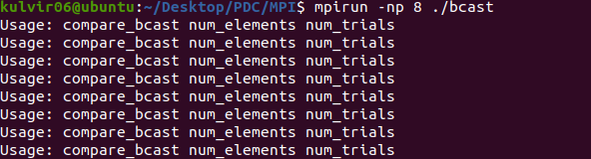

**Inference  
The program successfully implements the broadcast algorithm in MPI as seen in the output**